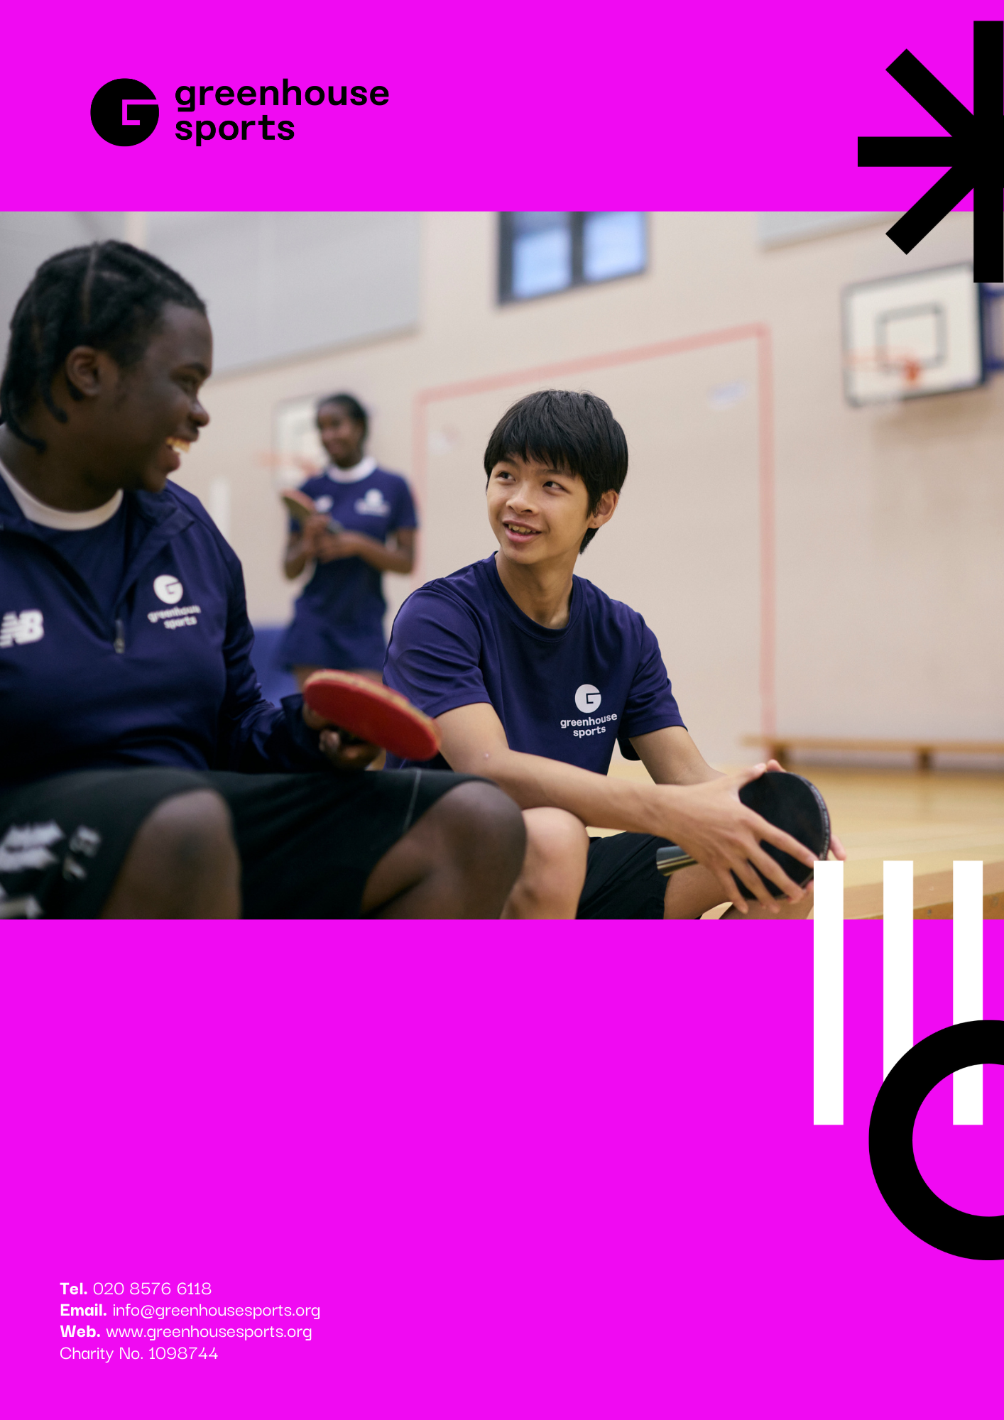

Greenhouse Connect – Safeguarding Considerations
Introduction

The Greenhouse App, which will be launched as Greenhouse Connect has been designed to improve data collection to assist our evaluation of the Greenhouse programme as the current methods face significant challenges, including limited access to personal devices in schools, lack of dedicated time for self-reflection, and survey fatigue from repetitive formats.

The tool will ensure that the barriers currently faced by Coach-mentors in engaging parents or school leadership, as well as a lack of suitable methods for easily logging progression are key drivers for the need to innovate and modernise through this digital application.

The system will be designed with multiple functions tailored for participants, coaches, and parents/guardians. Features include digital surveys, safeguarding reporting, enrichment opportunities, progress tracking, and case study development.

Safeguarding Participant’s data

A key aspect of the process since the appointment of Big Lemon in February has been to liaise across the organisation and create a backlog of ‘user stories’ and features that could be implemented. With each feature, the project group (Camilla Knight, Nick Dunnett, Nita Sullivan, Big Lemon) have discussed and assessed the ways that a particular feature will impact the non-negotiable safeguarding requirements that are absolutely essential to the successful roll-out of the new system.

The log of potential risks and the ways that these risks will be mitigated is shown below, and will continue to be updated in the lead up to the full launch of the system in early 2027:

Risk | Mitigation
Sensitive' or 'personal' data can be viewed within the app (such as DOB, address, consents, medical conditions) | The app will not hold this information directly, and the information will never be 'surfaced'. Instead parents/guardians will be asked to re-register their child, and the data will be updated on the internal Greenhouse server. Therefore the level of information that can be accessed, relates solely to their progression across the curriculum and their survey responses. Data related to the children will continue to reside within Views and the Microsoft SQL on-premises SQL server.
Back-end' of the app is vulnerable to being breached and the data stolen. | MongoDB protects data through strong security measures like verified logins, role-based access to control what users can do, and encryption to keep information safe both when stored and when shared over networks. It also includes monitoring and auditing tools for compliance, and network controls to block unauthorized access. In the cloud (MongoDB Atlas), many of these protections are built-in and automated, making it easier to stay secure. Following best practices such as limiting access, keeping systems updated, and enforcing secure connections helps ensure sensitive data remains safe.
Front-End' of the app is vulnerable to being hacked/breached | SSL certificates enforce encryption in transit between the app and our API that links the data to the MonoDB listed above.  Personal or sensitive data related to the participants will not exist within the app database, therefore mitigating risk.
Participants could be de-motivated by seeing a poor score or view from the coach | The participants will not be told when a coach has moved them from one level to another. Once they have achieved certain levels, they will receive a 'badge' within the system, but this will not be explicitly linked to a 'score'
Messages could be sent privately. | Messaging is one-way, from coaches to selected groups of users/parents. Coach-mentors will be requested to keep communications centred on successes, termly updates, links to articles/videos that will improve psycho-social skills as well as improve skills.
Photos could show participants that have not consented to their image being shared | Coaches will be able to post pictures to groups of parents & participants through the app. As per the current process, they will need to review the consents within the participant profile before posting any pictures.
Data cannot be provided by young people under the age of 13 | Having all participants provide their responses and views of their progress was one of the key motivators for creating the app, however the age of consent for young people to provide their own information is 13. Participants under the age of 13 will be linked to their parents account, and when a response is due, the parents will be asked to support their children's progress by handing them their device and supporting during the process.
A participant registers themselves as their parent | When parents registers their child, or children, they will be given a unique code that they then need to input to link their profile to that of their children. These steps will ensure that there is sufficient steps to link a parents email to the app profile of their child.
Someone maliciously registers themselves as the parent | Children who input the same email address for next of kin and the child will be flagged for an admin to review. Where this occurs, the participant profile will be investigated and their parent contacted. Until such time as the parent has verified their connection to the child, the account will be suspended.



